Assignment 2 Design Rationale
Requirement 4: Static factory’s staff benefits

UML Diagram:
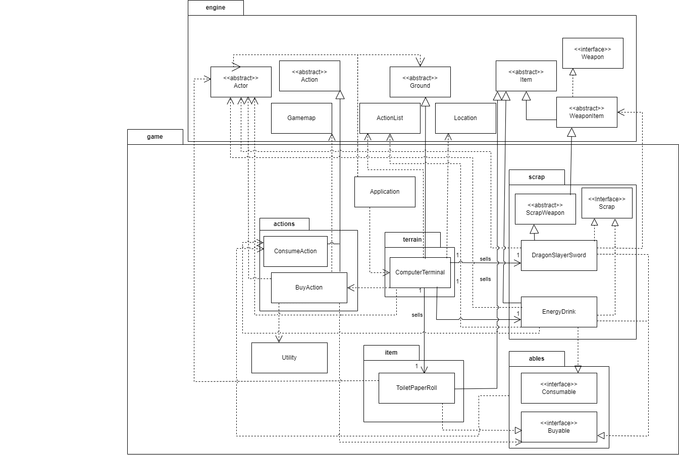

Design Goal:

The design goal for this assignment is to enhance the game system by introducing the ability for actors to buy items from a computer terminal. This feature enriches gameplay by providing a new interaction option for actors while maintaining adherence to object-oriented design and SOLID principles.

Design Decision:

In implementing the buying system, the decision was made to introduce a new class, ComputerTerminal, which extends the existing Ground class. This design choice allows for seamless integration of the buying functionality into the game world.

The ComputerTerminal class provides a method allowableActions() that returns an ActionList containing BuyAction instances for different buyable items. Each BuyAction instance is instantiated with a specific buyable item, such as EnergyDrink, DragonSlayerSword, or ToiletPaperRoll.

The BuyAction class is responsible for executing buying actions. It interacts with actors and buyable items to deduct credits from actor balances, handle special events (such as price adjustments or non-printing of items), and add bought items to actor inventories. The buyable items implement the Buyable interface, ensuring consistent behavior across different types of buyable items.

This design promotes modularity and maintainability by encapsulating buying logic within the BuyAction class and allowing for easy extension of buyable item types through the Buyable interface. It also adheres to the Single Responsibility Principle (SRP) by assigning specific responsibilities to each class.

Alternative Design:
One alternative approach could involve directly embedding buying logic within the ComputerTerminal class, where each buyable item's behavior is hardcoded. However, this approach would violate the Open/Closed Principle (OCP) and lead to less flexible and harder-to-maintain code.

Alternative design
public class ComputerTerminal extends Ground {
@Override
public ActionList allowableActions(Actor actor, Location location, String direction) {
ActionList list = new ActionList();
// Hardcoded buying logic for each item
if (actor.getBalance() >= 10) {
list.add(new BuyAction(new EnergyDrink()));
}
// Similar hardcoded logic for other items...
return list;
}
}

Analysis of Alternative Design:

The alternative design is not ideal because it violates several design principles:

Open/Closed Principle (OCP): Hardcoding buying logic within the ComputerTerminal class makes it difficult to extend the system with new buyable items without modifying existing code. This violates the OCP, which states that classes should be open for extension but closed for modification.

Single Responsibility Principle (SRP): Embedding buying logic within the ComputerTerminal class violates the SRP by mixing concerns related to terrain features and buying functionality. Separating buying logic into the BuyAction class adheres more closely to the SRP, promoting clearer code organization and easier maintenance.

Interface Segregation Principle (ISP): The alternative design does not consider ISP, as it does not provide a clear separation of interfaces for different types of behavior. Introducing the Buyable interface allows for a more modular and cohesive design, where buyable items implement only the methods relevant to buying functionality.

